# 

# Locator in Selenium and syntax:

**=========================================**

**IN By class having 8 locators**

**1.ID :**

**EX: driver.findElement(By.id("datepicker")**

**2.Class Name> example**

**ex-driver.findElement(By.name("username"));**

**3.Tag Name**

**4.Linked text**

**5.Partial Link Text**

**6.Xpath**

**7.Css selector**

**8Relative locator**

**In direct Locator is:**

**1.ID**

**2.Class Name**

**3.Tag Name**

**4.Linked text:>It will give exact Text even though if you missed space or upper case/lower case , it will not match .it is exact match and it is case sensitive .**

**If it exactly matching than it will work otherwise not .**

**5.Partial Link Text: it will check partial and return web element, puspaanjali > puspa is there then also it will search and return web element**

**X path : it is an way/Technique to find an element in a structure Tree document.**

**1 Absolute Xpath and Relative xpath**

**Absolute xpath: it will search entire dom ,if it is matching then pick the element**

**Ex- Entire earth state, city,apartnamnet floor hose no, it will traverse Node by note**

**Html/body/input/li/div/span**

**Relative xpath: It will go the dom and find the element which fall under the tag name**

**EX- i am a person name-puspa,staying bangalore work in cts some that**

**//span**

**Finding element with TagName:**

**==============================**

**//a**

**//img**

**//input**

**Finding element with single Attribute and value :**

**=================================**

**//tagname[@attribue=’value’]**

**Or**

**//tagname[@attribute=”value”]=>when we have multiple string**

**Allowed ‘ ‘ and “ “**

**Its case sensitive**

**ex=//input[@type='email']**

**3.Finding element with multiple Attribute and value :**

**===========================================**

**//tagname[@attribue1=’value1’ and @attribue2=’value2]**

**Example ://button[@class='submit-btn' and @type='submit']**

**Or**

**//tagname[@attribue1=’value1’ or@attribue2=’value2]**

**Example: //button[@class='submit-btn' or @type='submit']**

**4.Finding element with Index based xpath**

**===================================**

**(xpath)[index]**

**Example**

**//a[4]> all the hyperlink matching with 4th index**

**5.Contains function**

**=================**

**When we failed to find id,class name,and if its dynamic value than we can go with this function , even its partial match value matches its work.**

**//tagname[Contains(@atrribute,’value’)]**

**ex-//a[contains(@href,'twitter.com')]**

**6.Text Function():**

**===================**

**//tagname[text()=’Text to find’]**

**//a[text()='Practise']**

**7.Wirldcard ;**

**=====================**

**\*>>when you are not sure about what is the tag name ,but use condition should match,all the tag.**

**//*[text()=’text to find’]**

**8.Tex function with contains:**

**//tagname[contains(text(),’text which you are looking for it’]**

**Exception faced in selenium**

**=========================**

**1- SessionNotCreatedException - When browser failed to start**

**2- Invalid argument exception - When no http or https is provided**

**Another scenario-Invalid argument exception when we are trying to upload the file but path is incorrect**

**3- java.lang.IllegalArgumentException: Keys to send should be a not null CharSequence**

**Example - driver.findElement(By.id("")).sendKeys(null);**

**4- NoSuchElementException - if element not found**

**5- ElementNotInteractableException: element not interactable - when element or**

**field is disabled**

**6- InvalidSelectorException - Selectors not valid**

**7-UnexpectedTagNameException - When you use Select class in Selenium but element does not have select tag**

**8- StaleElementReferenceException: stale element reference: element is not attached to the page document - Element is loosing its reference or not**

**attached to DOM-(when page refresh , then the lament not present in the DOM ).**

**Example : try to login git hub provided user id and pw and sign in , username is present here but password not here again if i try to reload the last password then i will get the StaleElementReferenceException**

**WebDriver driver= new ChromeDriver();**

**driver.manage().window().maximize();**

**driver.get("https://opensource-demo.orangehrmlive.com/web/index.php/auth/login");**

**Thread.sleep(2000);**

**WebElement element= driver.findElement(By.name("username"));**

**element.sendKeys("Anjali");**

**driver.navigate().refresh();**

**element.sendKeys("Anjali");**

**driver.close();**

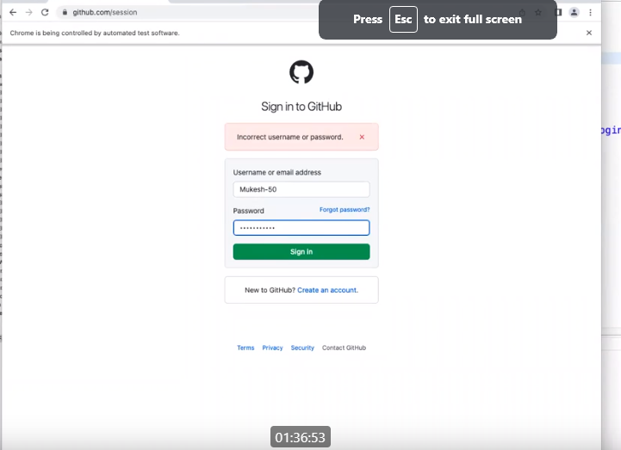

**9) Unhandled Alert Exception : When ever alert /confirm/prompt is active and if you try to capture screenshot and try to interact with element it will through the error .**

**Ex- one page there and alert is active we don’t do dismiss or accept and try to send anther value though send key()**

**10) No Alert present exception:If alert is not present .**

**11)No such window Exception:if window does not exist**

**Ex: if we give wrong window handle which is doesn’t exist then it will through the array**

**1- SessionNotCreatedException - When browser failed to start**

**2- Invalid argument exception - When no http or https is provided**

**3- java.lang.IllegalArgumentException: Keys to send should be a not null CharSequence**

**Example - driver.findElement(By.id("")).sendKeys(null);**

**Another scenario - InvalidArgumentException- when trying to upload file but path is incorrect**

**4- NoSuchElementException - if element not found**

**5- ElementNotInteractableException: element not interactable - when element or**

**field is disabled**

**6- InvalidSelectorException - Selectors not valid**

**7-UnexpectedTagNameException - When you use Select class in Selenium but element does not have select tag**

**8- StaleElementReferenceException: stale element reference: element is not attached to the page document - Element is loosing its reference or not**

**attached to DOM-**

**9- UnhandledAlertException - Whenever alert/confirm/prompt is active and if you try to capture screenshot or try to interact with element it will throw UnhandledAlertException**

**10- NoAlertPresentException - if alert is not present**

**11- NoSuchWindowException - if window handle does not exist**

**12- NoSuchSessionException - if we call quit then try to access again**

**13- NoSuchFrameException - if frame is not present**

**14- TimeoutException: timeout: Timed out receiving message from renderer: -0.003 - pageLoadTimeO**

**15-Waiting for conditions to resolved(webDriver wiat).**

**16.IOException-when failed to take the screenshot .**

**17.UnsupportedOperationException :if the underlying implementation does not support screenshot capturing.**

**Working with Git Hub**

**==========================**

**Step1:Install Git first** [**https://git-scm.com/download/win**](https://git-scm.com/download/win)

**Step2: Login to your Github provide your credentials**

**Step3:Create one Repositary**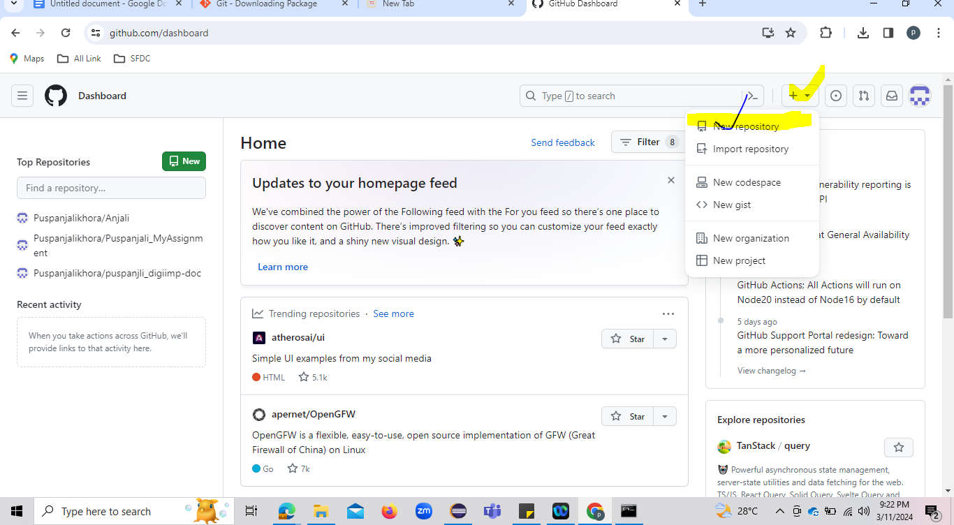

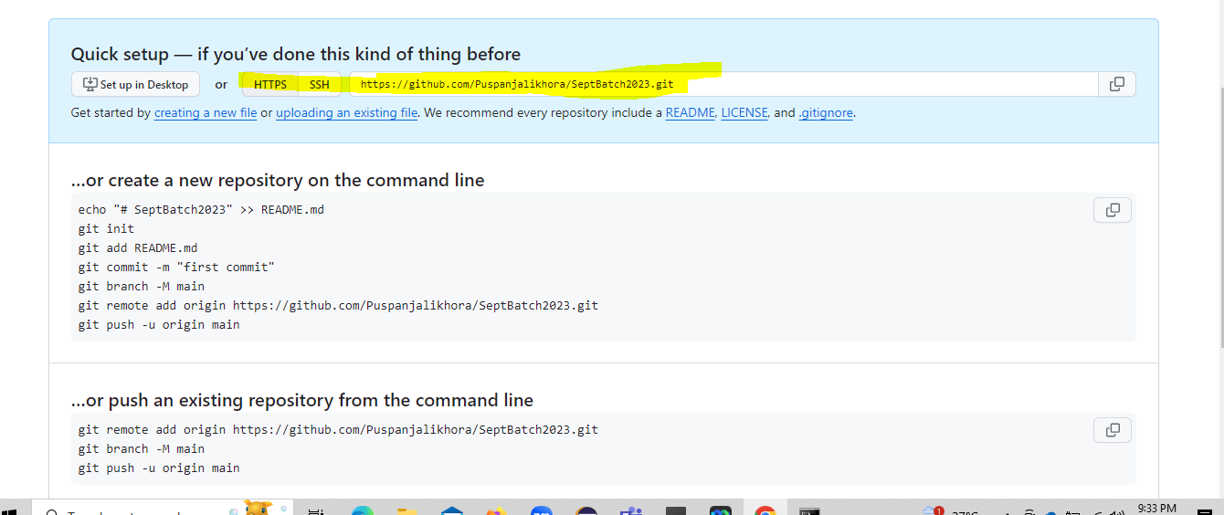

**Open Cmd> copy the project location from ID and past it in cmd.**

**dir/o > To know the number of folder present in the project**

**cls> for clear**

**Steps :and command**

**==================**

**git add>> git add a particular file (ex : git add <file_name>)**

**git status> to know the status of added file / remove file**

**git add . >> it will add all the file from the project**

**git commit -m "first commit" >>>-m is mandatory to add for commit the code**

**git log> We get to know the total all the INFOs of commits**

**git remote add origin** [**git@github.com**](mailto:git@github.com)**:Puspanjalikhora/SeptBatch2023.git>> one time activity(when we do first time)**

**git branch>We get to know the branch name (current branch name)**

**If we faced this issue >>This key is not known by any other names.**

**Are you sure you want to continue connecting (yes/no/[fingerprint])? yes**

**Warning: Permanently added 'github.com' (ED25519) to the list of known hosts.**

**git@github.com: Permission denied (publickey).**

**fatal: Could not read from remote repository.**

**Solution:is here**

**git remote set-url origin** [**https://github.com/Puspanjalikhora/SeptBatch2023.git**](https://github.com/Puspanjalikhora/SeptBatch2023.git)**(while using https**

**git push -u origin master>> it will push your code to current branch**

**How to create branch>**

**checkout -b QA master**

**git checkout QA**

**git checkout git checkout -b Dev QA**

**Example**

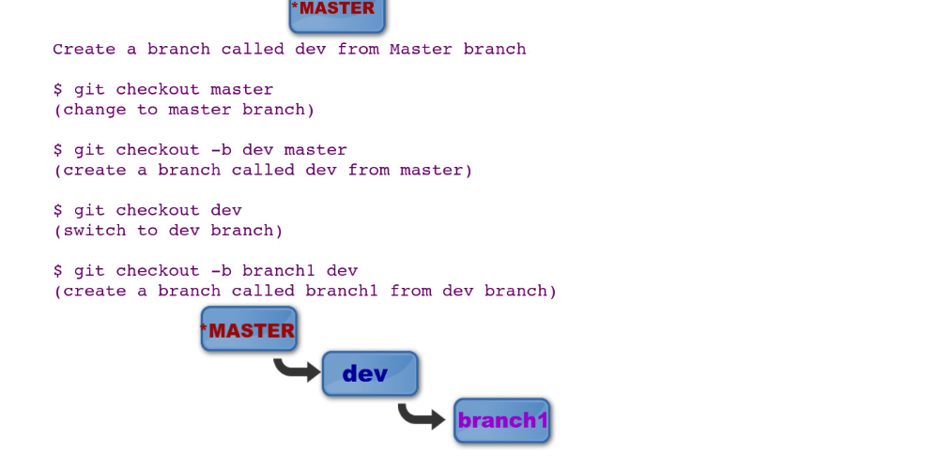

**git reset --soft HEAD^ >>>>moving the mistakenly committed files back to the staging area from the previous commit, without cancelling the changes done to them.**

Mistakenly i commit the code in master branch instate of my local branch so **without cancelling the changes done in master how to undo**

**ANs>>**

**git reset --soft HEAD^**

**git checkout master >>>>** command to switch the branches (here switching for master branch)

**git branch>>we get the status of the actual branch name**

**use "git restore --staged <file>..." to unstage>>>**

**Clone from existing repo code into Local system**

**git clone -b master (“copy the repo url”) https://github.com/Puspanjalikhora/SeptBatch2023.git**

**git clone -b master https://github.com/Puspanjalikhora/SeptBatch2023.git**

**Cloning into 'SeptBatch2023'...**

**dir /o**

**Pulling the code from repo**

**===========================**

**git pull origin master**

**git log --oneline>>>> we get to know the overall information about what code push or removed**

**git reset --hard 27e32b4—>if already code added into the local and undo**

**git pull origin master>>**